Smart Drug Delivery System

Contents
Smart Drug Delivery System
1. Introduction 2
2. Literature Research 2
3. System Features, Architecture, Process and Technologies 2
3.1 System Features 2
3.2 System Architecture 2
3.3 System Process 2
3.4 Technologies 2
4. Identifying Assets 2
5. Security Requirements, Challenges and Functions 2
5.1 Security Challenges 2
5.2 Basic Requirements 2
5.3 Security Management Requirements 2
5.4 Data Center Security Requirements 2
5.5 Server Security Requirements 3
5.6 Network Security Requirements 3
5.7 Platform Security Requirements 3
5.8 Data Security Requirements 3
5.9 Key Management Requirements 3
5.10 Identity and Rights Management Requirements 3
5.11 Monitoring and Security Incident Management Requirements 3
5.12 Vulnerability Management and Security Testing Requirements 3
6. Entry Points 3
7. Threat Matrix 3
8. Threats, Attack Techniques, Countermeasures 3
9. Rating Threats 3
10. Privacy Issues and Solutions 3

Introduction
IoT’s incorporation allows manufacturers of medical devices to design and develop efficient drug delivery systems. It allows physicians to treat and prescribe medicines to patients at the comforts of their home, provides new healthcare technologies that allow remote patient treatment, regardless of where they are. A drug delivery system based on IoT ensures accurate dosage control. The integration of IoT Sensors can also show greater accuracy and reliability in blood infusions, allowing precise dose administration depending on age, weight and health conditions. IoT makes it possible to produce personalized medicines for each patient to facilitate robust delivery of medicines to remote people.
The project that we will be doing is a smart analyzer which collects medical data from the human body using its biomedical sensors, sends this medical information of the patient to a server for review of the data and for generating an unique prescription for that patient. Since the lack of doctors and nurses are known throughout the world, a machine learning algorithm will be used to assist the staff that will make the jobs of these people much easier. If the algorithm fails to create a prescription for the patient’s disease, the data will be transferred to an local clinic for a manual treatment.
Our project can also be used as a monitoring system of the people so that pandemics and illnesses can be prevented. If everyone used this system, governments would have easily monitored the infected population and the pandemic of Covid-19 could have been prevented easily.

Literature Research

The Smart Drug Delivery System and its Clinical Potential (Dong Liu, Fang Yang, Fei Xiong, Ning Gu)
Recent advances of smart nanoplatforms for targeting drug delivery are highlighted. Furthermore, the clinical translation obstacles faced by these smart nanoplatforms have been reviewed and discussed. Future directions and perspectives of stimuli-sensitive DDS in clinical applications are presented. It describes the design rationale of smart drug delivery nanoplatforms, Organic-inorganic hybrid smart nanoparticles.It was also concluded that advanced nano DDS systems will make the future studies of medicine much more efficient.
Smart Drug Delivery System and a Method of Implementation thereof (Janice Nickel, Peter Hartwell, Sean Zhang)

This paper mainly reports the inventions capabilities such as its ability to give drugs to the patients based on the data that is analysed by the invention. It includes a biological sensory component, an analytical component coupled to a drug delivery component for delivering a drug to a host. Also may figures are presented such as, energy harvesting systems, block diagrams of the system, an RFID system that can be used in conjunction to the system.

Fabrication and characterization of a smart drug delivery system: microsphere in hydrogel (Xien Zheng Zhang, Patti Jo Lewis, Chih Chang Chu)

This paper observed the temperature sensitive properties of the DDS s were inspected. Also releasing the modelled drugs at different temperatures are observed.

System Features, Architecture, Process and Technologies

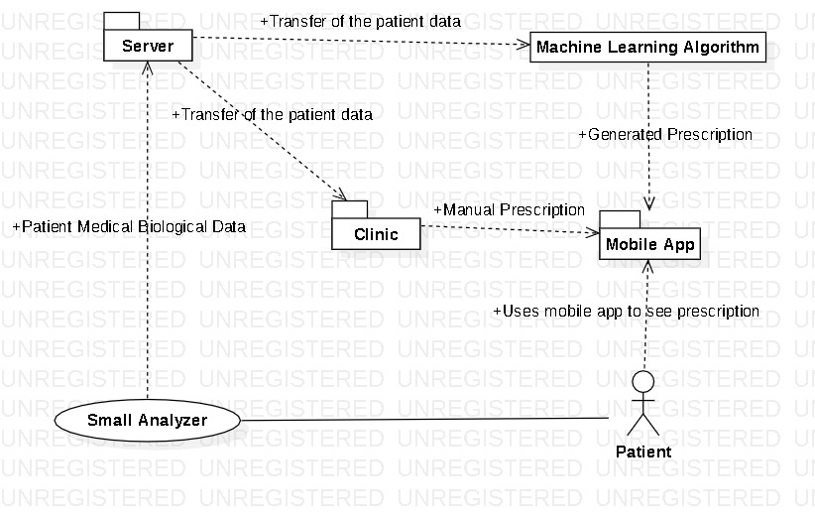

System Features

Patient Side
- Examining and analysing the human body and sending the information to a server for automated prescription generation.
- Analytics of user’s response to the given dosage
- Another functionality is the machine learning algorithm that will be used on automated prescription generation. Since we know the doctors and nurses are outnumbered by the population of our world, staff won't be needed to observe patients data 24/7. The longevity of the checkups of these patients will be determined by their past medical information and their personal information such as age, gender etc.
- A smart biomedical chip will be implanted to the most crucial part of the human body and also the part that will not harm a human. After the implantation the devices only capability should be to analyse the medical information of the subjects body and send it to the server.

- A mobile application for patients to check their prescriptions

Clinic Side

- Higher level of access to the mobile app for clinics to modify the prescriptions and adding manual prescriptions

- Ability to communicate with the patient through the mobile application

System Architecture

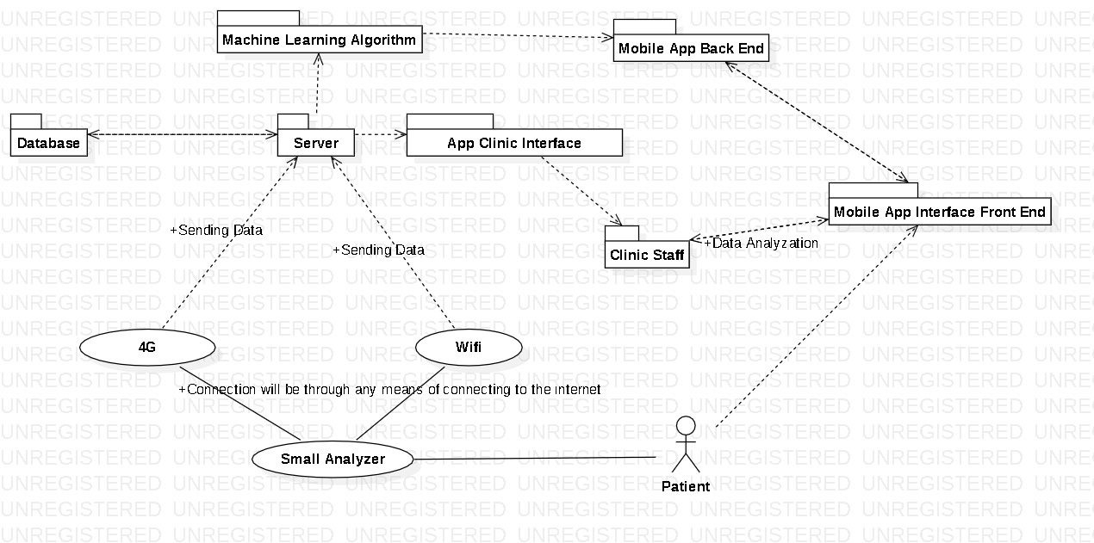
A IOT biomedical chip that keeps health metrics of a human and sends periodic updates to a web server.
A web server handling requests from the biomedical chip, returning a recommended prescription that can be viewed on a mobile app alongside with the recommended dosages for each medication.
A database which will keep the patient’s medical data and their prescriptions, their data for the mobile app.
A mobile app for users to track their medication and for clinics to do manual prescription.

System Process
Users register to a mobile app where they can track their current health metrics,
Periodic transfers of the patient's medical data to the server using the IOT biomedical chip.
When a disease is encountered by the biomedical chip, users will get a notification from the mobile app.

Technologies

Technology | Details
Communication Protocol: TCP/HTTP | Handling of the communication between the IOT device and a web server using REST architecture.
Architectural Style: REST | Handles transfer of the data generated by the chip with server, also used in backend of the mobile app to receive the generated prescription from the server.
NodeJS | Will be used on the Mobile Application Backend and Main Server to implement an efficient REST service.
Biomedical Chip | Collects patient’s medical data and sends it to the server.
Machine Learning | Used by server for generation of a specified prescription for the patient.
Mobile Application | Will provide an user interface for patients to see their prescriptions, will receive the generated prescription from the server.

Identifying Assets

Assets | Type | Details
Biomedical Analyzer Chip | Hardware | Each patient will have one biomedical data analyzer chip injected in their body. Analyzes patients medical data.
Mobile Application | Software | The main interface for patients and clinics to access the prescriptions and medical data.
Biomedical Chip Data | Information | Precise dose administration information depending on age, weight and health conditions
Cloud Infrastructure | Hardware / Software | Includes main server where all patient data collected and its database. Also includes mobile app backend.
Generated Prescription | Information | Personalized prescriptions and dosage control uniquely generated by the machine learning algorithm.

Security Requirements, Challenges and Functions

Security Challenges

The device should be connected to the internet when sending data to the server. Since the device won't be able to provide any medication inside the subject and it will only analyse the medical information, there won't be any harm done to the subject.
The only security concern may be the information that is sent to the server and the data that is stored, should not be exposed to any data manipulation. This will be crucial because this might turn into clinics giving the subjects the wrong dosages and the wrong medication that will make the case of the patient more severe or maybe even die in the end.
Also the data that is being read by the device in the subjects human body might give wrong data to the server. This can be prevented by the local clinics contacting the subject if any anomalies in the data occurs. Because of this, before every prescription prescribed by the local clinics, a physical check will be advised to both the local clinics and the patients.

Basic Requirements
The staff that will check and maintain the servers should be hired.
Confidentiality of sensitive medical data within the system should be provided to the user. Availability of the system should be given to the user, he/she should be able to access their biological data in the mobile app.

Security Management Requirements
An information security system should be implemented where the data that are being sent to the server should be analyzed and any suspicious activity among the data should be observed. Also this system should let the admins know where these suspicious activities are coming from and inform the admins on how to prevent these activities.

Data Center Security Requirements

Certain software and hardwares will be placed to the servers to secure the medical informations of the patients that have this medical monitoring device. The data center access must be very strict. Multi factor authentication should be used to confirm the identity of the people that want to gain access.

Server Security Requirements
Traffic should be encrypted and be behind TLS 1.3.
Protecting the server is very important, the firewalls should be upto date and the firewall should prevent many attacks that are coming their way. Regular integrity checks are necessary and downtime data losses should be observed. No important data should be lost during these server downtime durations. Any intrusions in the server should be detected.

Network Security Requirements
Every user should send their medical information through their own secure internet. Sending the informations through unknown and potentially vulnerable internet systems may result in the attackers tampering with the data through various attacks. So every user is advised to send their data through a known and secure internet system. These can be easily configured by the user through the mobile app that will be given with the device.

Platform Security Requirements
Latest patches, updates and releases of the software should be deployed swiftly. The latest patches of the machine learning algorithm should be changed quickly so that many new viruses or germs can be found and medicines can be prescribed quickly.

Data Security Requirements
Users data should be encrypted and should only be shared with the user and a local clinic. The data should be deleted if the patient wants to delete all the data that belongs to him. Data must not be shared with any third party institution.

Key Management Requirements

Key management best practices like key life cycle management, key compromise, recovery and zeroization, key storage and key agreement should be followed.

Identity and Rights Management Requirements
Every users data must be encrypted and their identity information must be stripped. Each permission and identity must be based on signature. Only permitted access must see their own authorized interface.

Monitoring and Security Incident Management Requirements

The clinic staff admin activities should be logged and monitored thoroughly so that there would not be any trespassers in the system. This way many suspicious activities can be easily tracked.

Vulnerability Management and Security Testing Requirements

The server and the small analyzer should be security tested against vulnerabilities, this is very important because any data leak or any vulnerability across these hardwares will cause many problems.

Entry Points

Entry Point | Type | Description
Biomedical Analyzer Chip | Hardware | This analyzer chip can only analyze the bodily medical information and send them to the server. Only a surgeon can get access to this hardware.
Database | Software | The database is accessed through the server by having the credentials of the database(IP,Username,Password). Since all the data is encrypted even the adversaries won't be able to understand anything from the raw data.
App Clinic Interface | Software | App clinic interface can be accessed by the clinic staff and the admins of the server.
Server | Hardware | The server can only be accessed through many factors of authentication. The admins can only gain access to the server.
Smart Drug Delivery Mobile App | Software | This application provides sensitive medical data to the user that has the biomedical chip in their body. By connecting to the server through wifi or mobile data, they will be able to see their biological information live.

Threat Matrix

Security Threats | S | T | R | I | D | E
Actors other than the patient accesses the mobile app  credentials of the patient. | x | x |  | x |  | x
Adversaries gain access to the server and changes the machine learning algorithm. | x | x |  |  |  | x
The database is compromised and the adversaries takes sensitive information into their own hands | x | x |  | x |  | x
The mobile app backend is compromised because of malicious actors and therefore doctors prescribe the wrong medicine to the patients. | x | x |  | x |  | x
The data that is being sent to the server through the internet can be manipulated through man in the middle attacks. |  | x
Malicious adversaries shut down the server through a DDoS attack. |  |  |  |  | x
The Clinic App interface is fallen into the wrong hands by hackers gaining access to the system. | x |  |  | x |  | x

Threats, Attack Techniques, Countermeasures

Theat #1 | Actors other than the patient accesses the mobile app  credentials of the patient.
Threat Target | Legitimate customer account credentials, patient’s medical data
Attack Techniques | Social engineering; phishing; database compromises; MITM attacks
Countermeasures | Multi-factor authentication, SMS and mail notifications

Theat #2 | Adversaries gain access to the server and changes the machine learning algorithm.
Threat Target | Patients and the Service
Attack Techniques | Social engineering; phishing; hacking; exploitation
Countermeasures | Having solid security standards and procedures, well-educated system admin team, patching and detecting vulnerabilities

Theat #3 | The database is compromised and the adversaries takes sensitive information into their own hands
Threat Target | Patients
Attack Techniques | Social engineering; phishing; hacking; exploitation
Countermeasures | Encrypting sensitive information

Theat #4 | The mobile app backend is compromised because of malicious actors and therefore doctors prescribe the wrong medicine to the patients.
Threat Target | Patients
Attack Techniques | Social engineering; phishing; hacking; exploitation
Countermeasures | Immediate action should be taken, patients should be informed and the prescriptions should be removed when the access is regained

Theat #5 | The data that is being sent to the server through the internet can be manipulated through man in the middle attacks.
Threat Target | Patients Sensitive Data
Attack Techniques | Man in the middle attacks
Countermeasures | Ensuring the connection to the system through a secure wifi connection. TLS encryption on communication, encrypted traffic.

Theat #6 | Malicious adversaries shut down the server through a DDoS attack.
Threat Target | Server
Attack Techniques | A DDoS Attack.
Countermeasures | A web application firewall can be implemented through software or hardware.

Theat #7 | The Clinic App interface is fallen into the wrong hands by hackers gaining access to the system.
Threat Target | Clinic App Interface and Clinics
Attack Techniques | A spoofing that lets people access to a user of the clinic app interface.
Countermeasures | A multi authentication system can be implemented so nobody other than the legitimate users can gain access to this system.

Rating Threats

Threat 1
Actors other than the patient accesses the mobile app
credentials of the patient.
Category | Description | Score
Damage | Damage is limited to a single patient account | 1
Reproducibility | Attack is not highly reproducible, only that patients data will be in the wrong hands | 2
Exploitability | Exploitation of this threat can be done by social engineering and unskilled people can learn the credentials of other peoples username and password through many ways. | 4
Affected Users | Single user in most scenarios | 3
Discoverability | This threat is highly discoverable as it can be accomplished using non-technical activities | 9
Overall Score |  | 3.8
Action | Defer

Threat 2
Adversaries gain access to the server and changes the machine learning algorithm.
Category | Description | Score
Damage | Damage is limited to the whole system | 9
Reproducibility | Attack is not highly reproducible, this kind of hacking is very rare | 2
Exploitability | Exploitation of this threat can be done by adversaries gaining access to the server by hacking tools. CTF can be given example as a means of hacking the server. | 5
Affected Users | All of the users are affected. | 9
Discoverability | This threat is highly rare as it can be accomplished using highly technical activities | 6
Overall Score |  | 6.2
Action | Mitigate

Threat 3
The database is compromised and the adversaries takes sensitive information into their own hands
Category | Description | Score
Damage | Damage is limited to the whole system | 9
Reproducibility | Attack is not highly reproducible, this kind of hacking is very rare | 2
Exploitability | Exploitation of this threat can be done by adversaries gaining access to the server and database and making changes to the database / collecting data from the database. | 9
Affected Users | All of the users are affected. | 9
Discoverability | This threat is highly rare as it can be accomplished using highly technical activities | 6
Overall Score |  | 7
Action | Mitigate

Threat 4
The mobile app backend is compromised because of malicious actors and therefore doctors prescribe the wrong medicine to the patients.
Category | Description | Score
Damage | Damage is limited to some patients | 7
Reproducibility | Attack is not highly reproducible, this kind of hacking is very rare | 3
Exploitability | Exploitation of this threat can be done by adversaries gaining access to the server and database and making changes to the database / collecting data from the database. | 9
Affected Users | Many of the users are affected. | 9
Discoverability | This threat is highly rare as it can be accomplished using highly technical activities | 5
Overall Score |  | 6.6
Action | Mitigate

Threat 5
The data that is being sent to the server through the internet can be manipulated through man in the middle attacks.
Category | Description | Score
Damage | Damage is limited to minimal amount of patients | 5
Reproducibility | Attack is not highly reproducible, this kind of hacking can be done by educated hackers. | 5
Exploitability | Exploitation of this threat can be done by adversaries attacking the connection that the patient has. | 7
Affected Users | Some of the users are affected. | 3
Discoverability | This threat is highly rare as it can be accomplished through tools that are very hard to learn. | 4
Overall Score |  | 4.8
Action | Accept

Threat 6
Malicious adversaries shut down the server through a DDoS attack.
Category | Description | Score
Damage | Damage is limited to the whole system | 9
Reproducibility | Attack is not highly reproducible, our server is not vulnerable to DDoS attacks.. | 1
Exploitability | Exploitation of this threat can be done by adversaries attacking the server. | 5
Affected Users | All of the users are affected. | 5
Discoverability | This threat is highly rare as our server is protected to this kind of attack.. | 3
Overall Score |  | 4.6
Action | Accept

Threat 7
The Clinic App interface is fallen into the wrong hands by hackers gaining access to the system.
Category | Description | Score
Damage | Damage is limited to the clinic app interface users. | 5
Reproducibility | Attack may be highly reproducible, any vulnerabilities in the clinic app interface may affect this threat. | 5
Exploitability | Exploitation of this threat can be done by adversaries trying to gain access to this interface through many means of exploitation like social engineering, sql injections.... | 7
Affected Users | Clinics that are using this system are affected. | 7
Discoverability | This threat is may be very common but measurements must be taken before this happens | 8
Overall Score |  | 6.8
Action | Mitigate

Privacy Issues and Solutions

GDPR

